USER MANUAL

Gutierrez, Maria Theresa

BSCS

Borromeo, Jacob

BSIT

**Operations of User Type**

This section contains the User’s Manual which consists of step by step instruction to help guide the user on how to operate the system

**Log in**

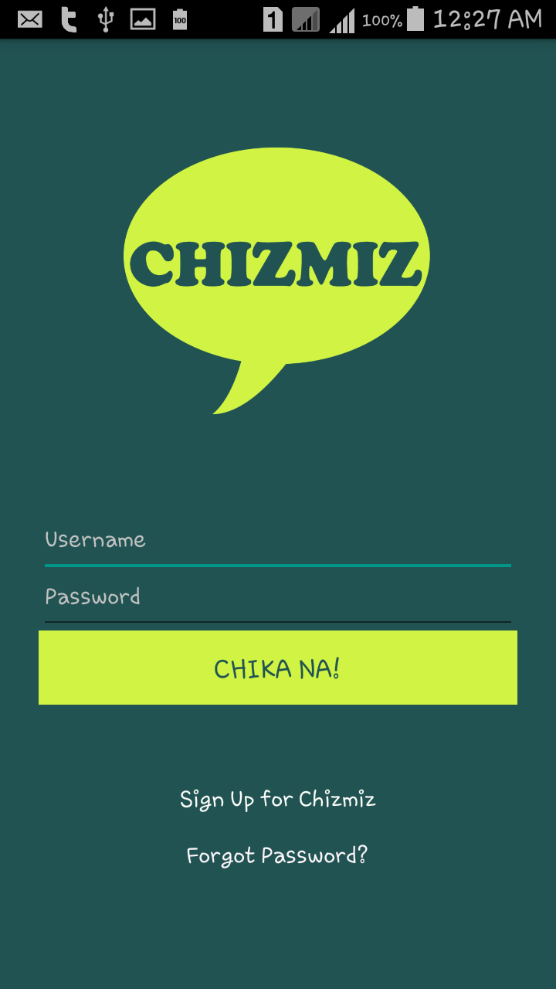

5

4

2

3

1

1. Input username
2. Input password
3. Click “CHIKA NA!” button.
4. Click “Sign Up for Chizmiz” to redirect to Sign up page
5. Click “Forgot password” to redirect to forgot password page

**Register**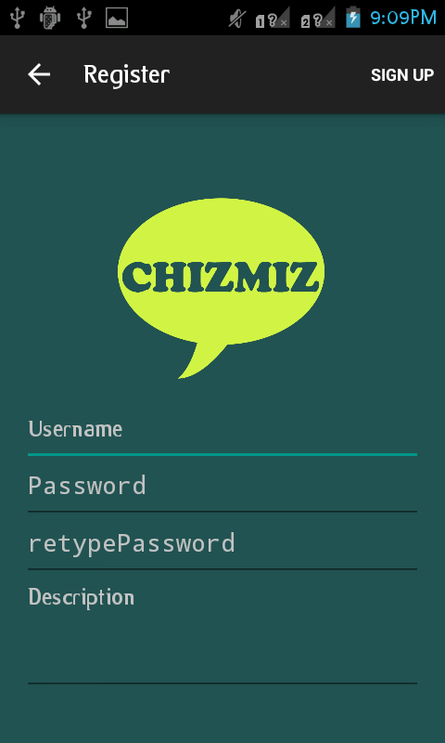

5

2

1

3

4

1. Input Username
2. Input Password
3. Input Retype Password
4. Input Description
5. Click “Sign up” to validate the new account

**Change Password**

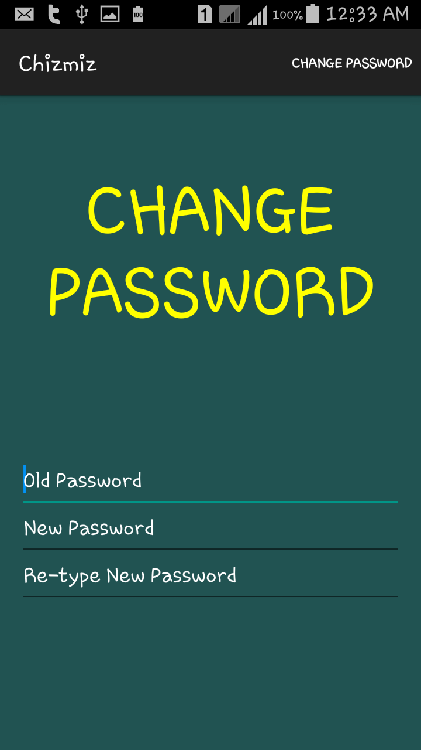

1

2

3

4

1. Input Old Password
2. Input New Password
3. Input Re-type Password
4. Click “Submit” to validate the password

**Update Account Page**

4

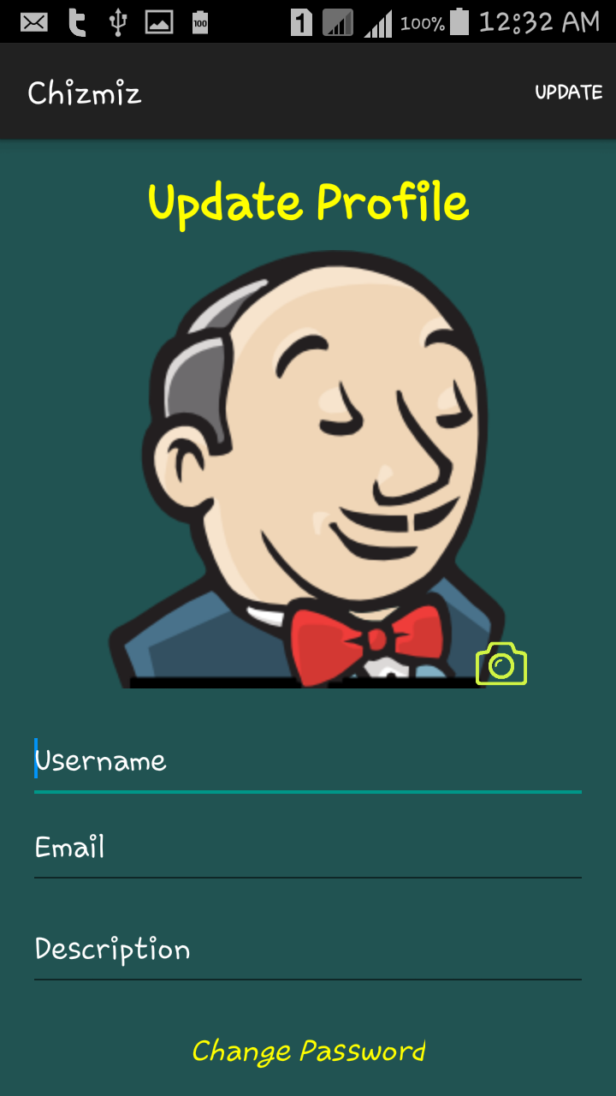

6

2

5

3

1

1. Input Username
2. Input Email
3. Input Description
4. Click “Submit” to change the Account Information
5. Click to change Profile
6. Click to change password

**Friend Request Page**

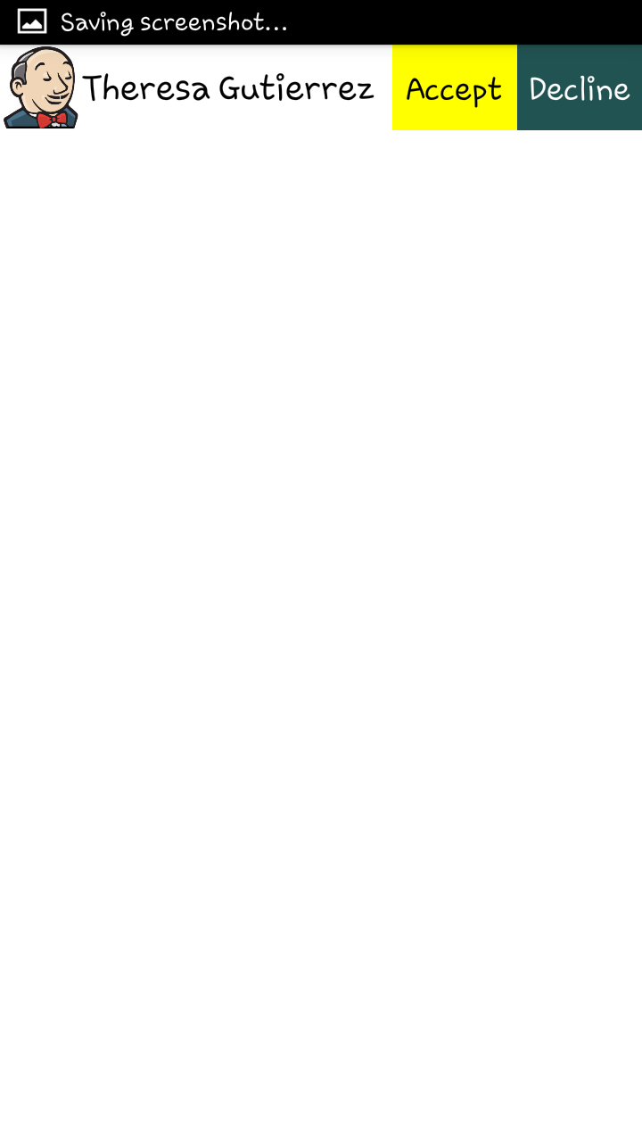

List of friend request only for viewing

**Home Page**

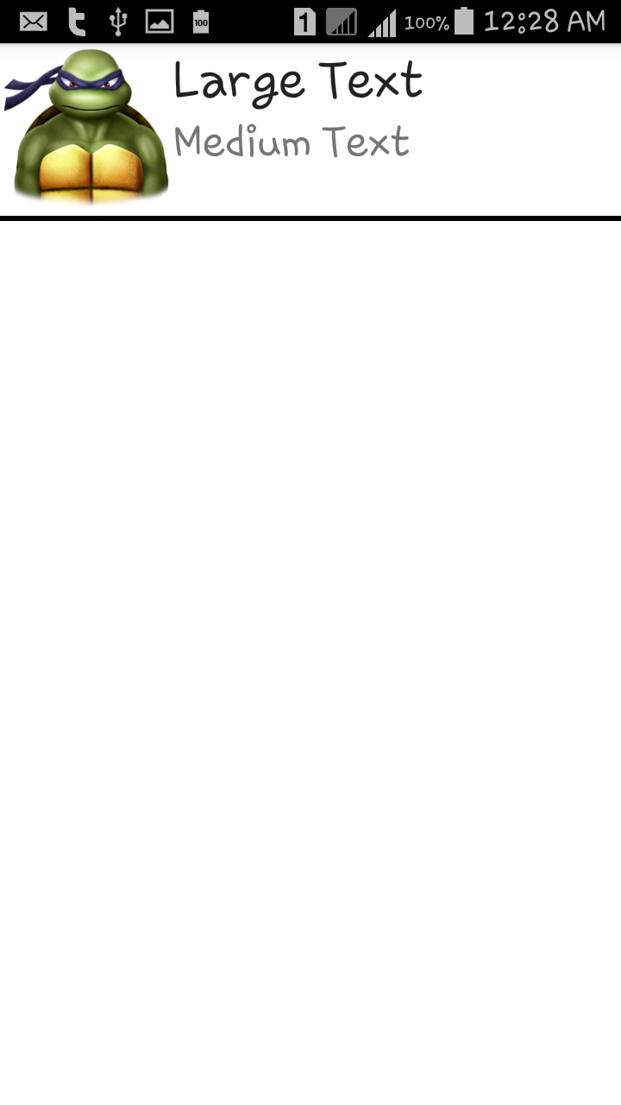

For viewing

About Page

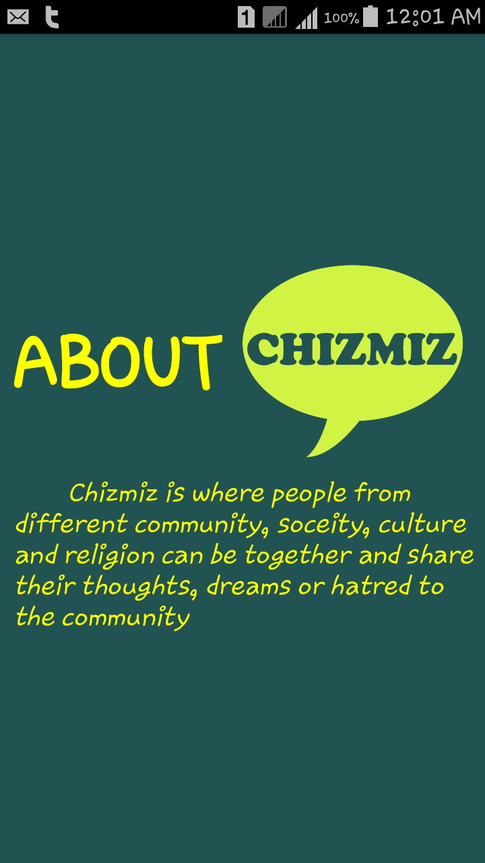

About page for viewing

Profile Page

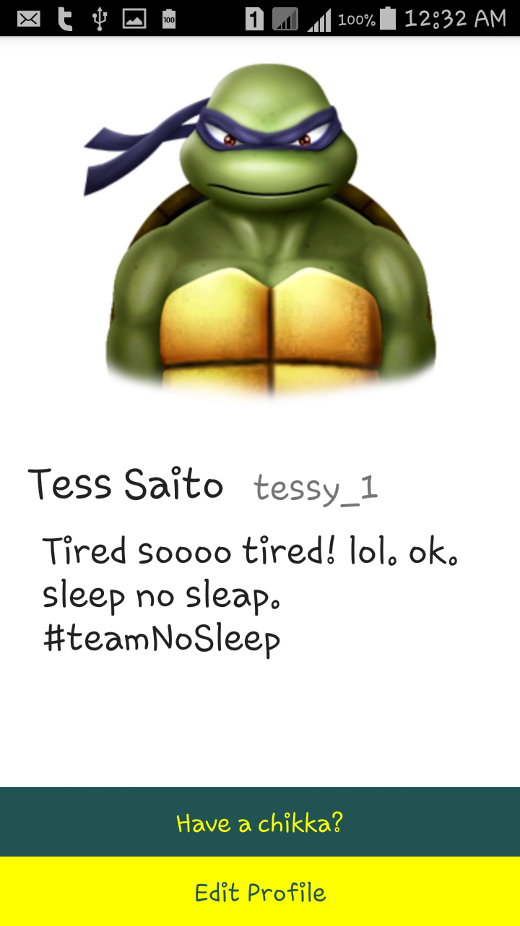

1. Click “Have a chikka?” to post status
2. Click “ Edit Profile” to edit profile

Reset password page

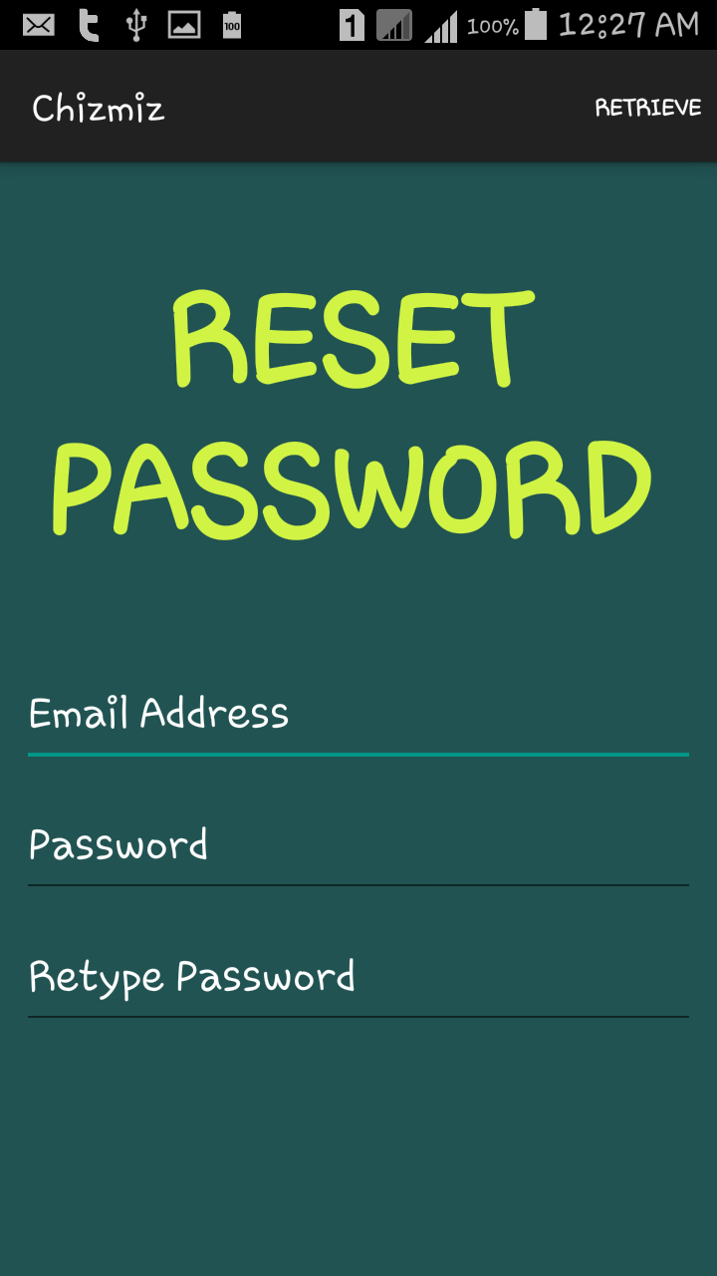

1. Input email address
2. Input password
3. Input retype password
4. Click "Retrieve”

Post Status page



1. Input status
2. Click “post”